Please follow the instructions here:

https://kubernetes.io/docs/tutorials/hello-minikube/
https://kubernetes.io/docs/tutorials/kubernetes-basics/deploy-app/deploy-intro/
https://kubernetes.io/docs/tutorials/kubernetes-basics/explore/explore-intro/
https://kubernetes.io/docs/tutorials/kubernetes-basics/expose/expose-intro/
https://kubernetes.io/docs/tutorials/kubernetes-basics/scale/scale-intro/
https://kubernetes.io/docs/tutorials/kubernetes-basics/update/update-intro/

Please write a document with screenshots and notes for major steps and commit it to your github repo.

Kubernetes Getting Started Lab Report
Student: Xie Xiangyu
Date: January 29, 2026
Environment: Windows 11, Docker Desktop, Minikube v1.37.0
Lab Duration: Approximately 2 hours

1. Lab Environment Setup

1.1 Minikube Installation and Startup
minikube start --driver=docker --image-mirror-country='cn'

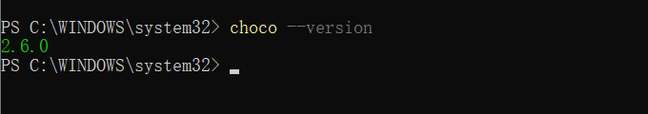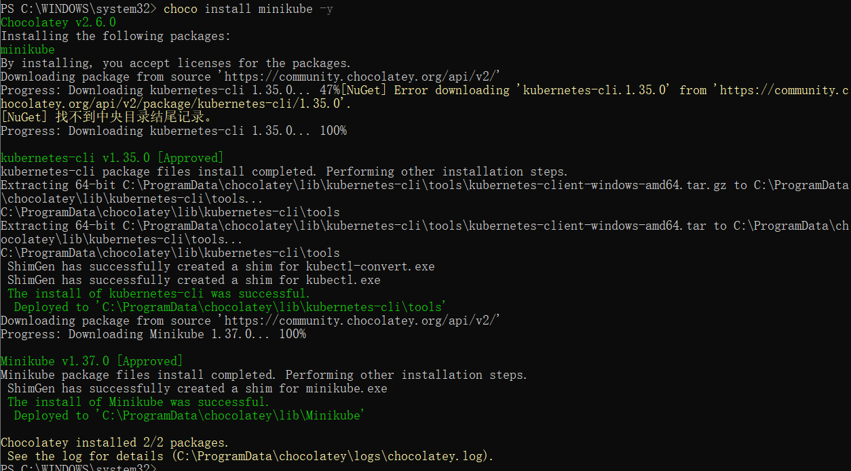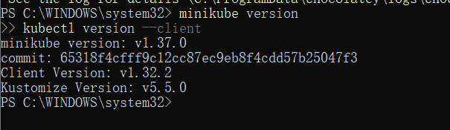

problems: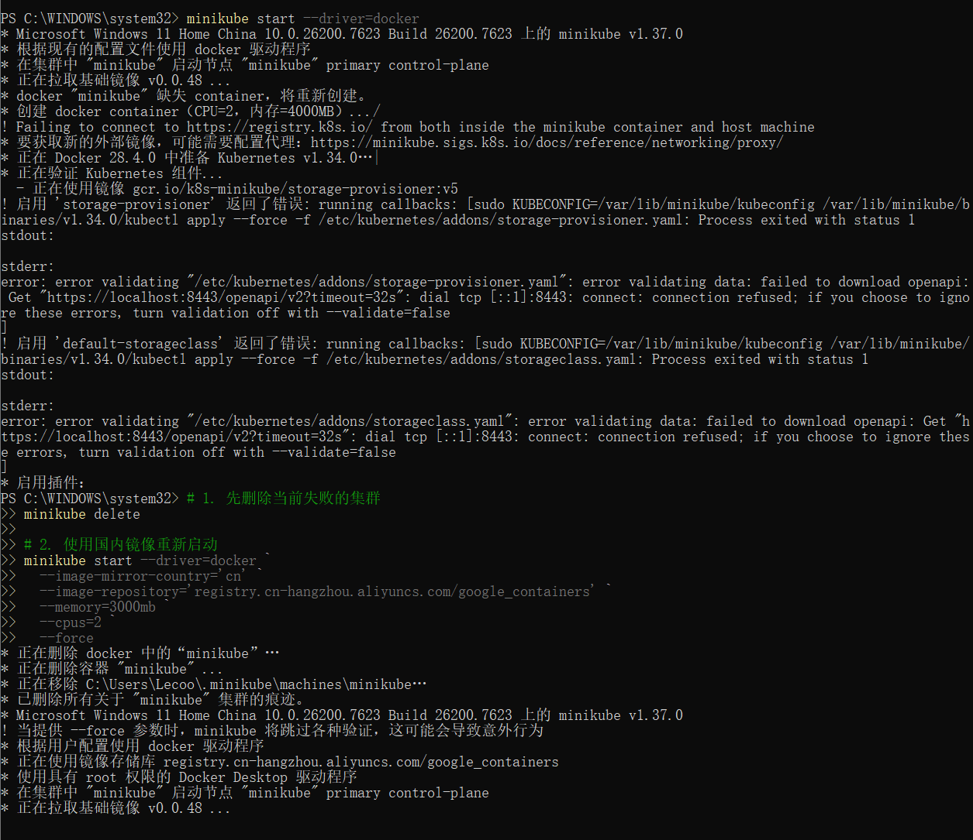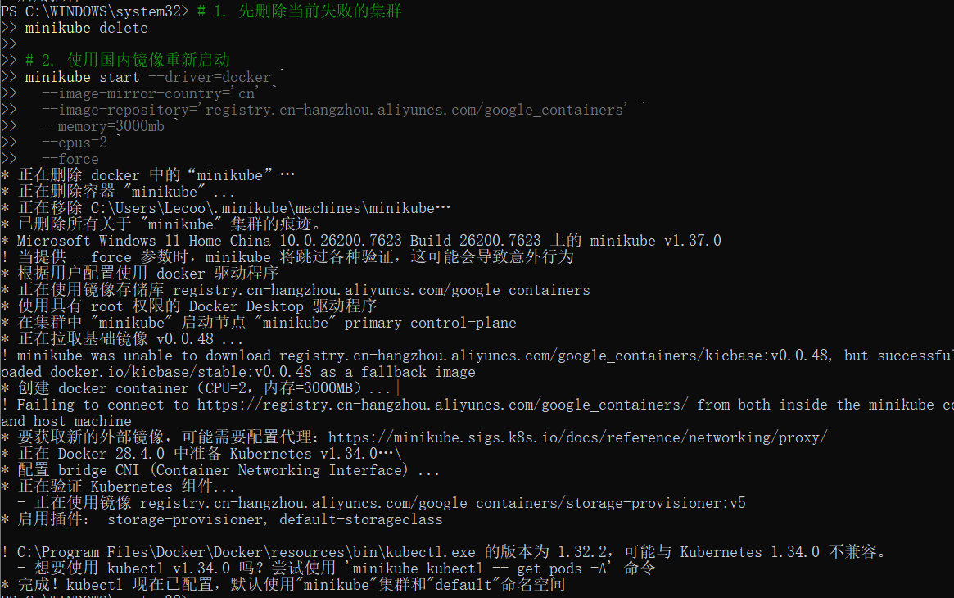1.2 Cluster Status Verification
minikube status
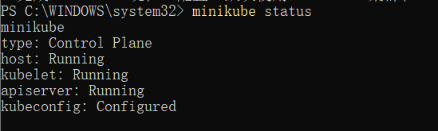kubectl get nodes

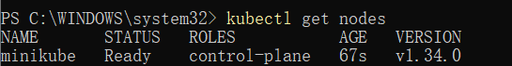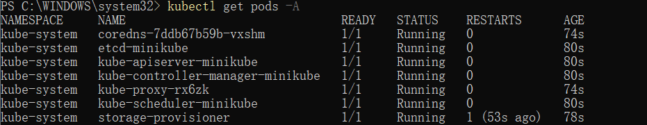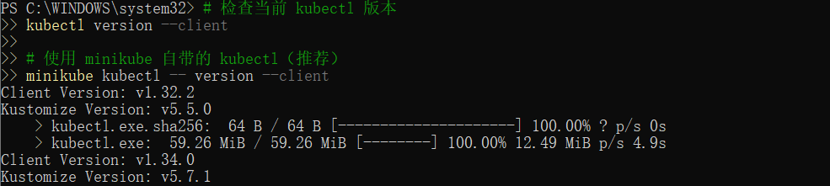2. Application Deployment

2.1 Creating Deployment
Problem: Network restrictions prevented downloading echoserver:1.4 image
Solution: Used pre-existing pause image in Minikube
kubectl create deployment hello-node --image=registry.k8s.io/pause:3.10.1
kubectl get deployments
kubectl get pods

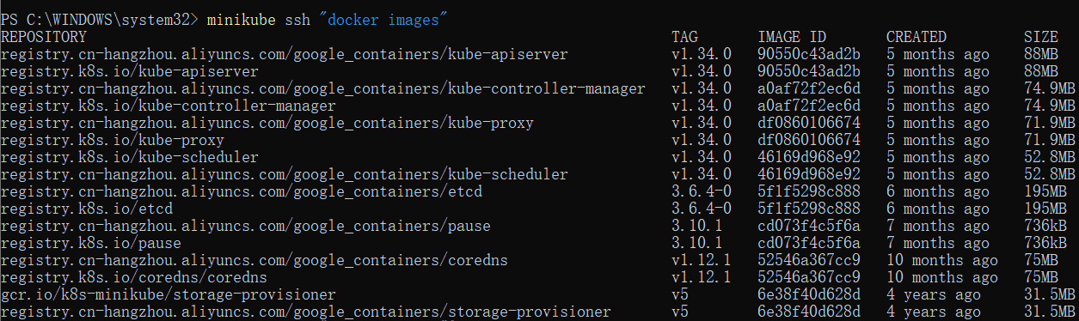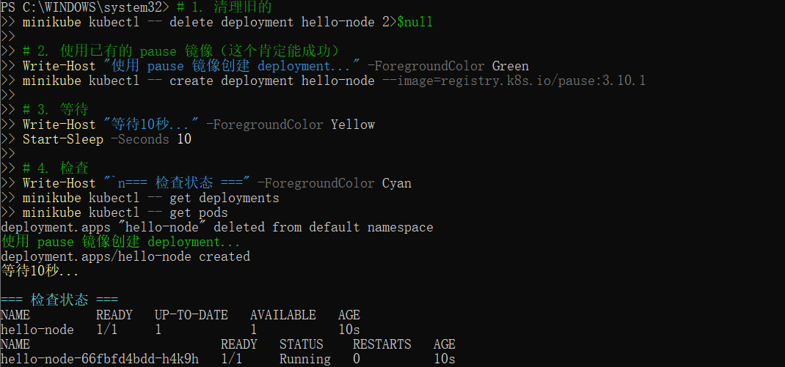3. Service Exposure

3.1 Creating LoadBalancer Service
kubectl expose deployment hello-node --type=LoadBalancer --port=8080
kubectl get services

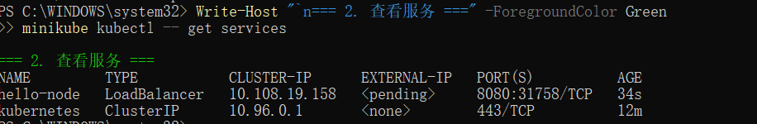4. Application Scaling

4.1 Scaling from 1 to 3 Replicas
kubectl scale deployment hello-node --replicas=3
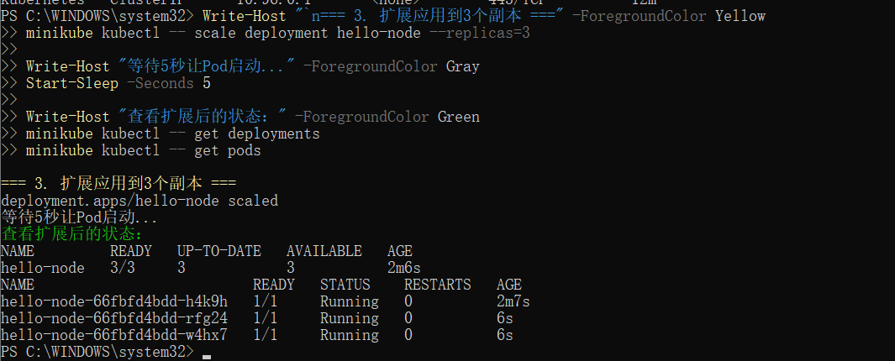kubectl get deployments
kubectl get pods

5. Application Update

5.1 Rolling Update to New Version
kubectl set image deployment/hello-node pause=registry.k8s.io/pause:3.9
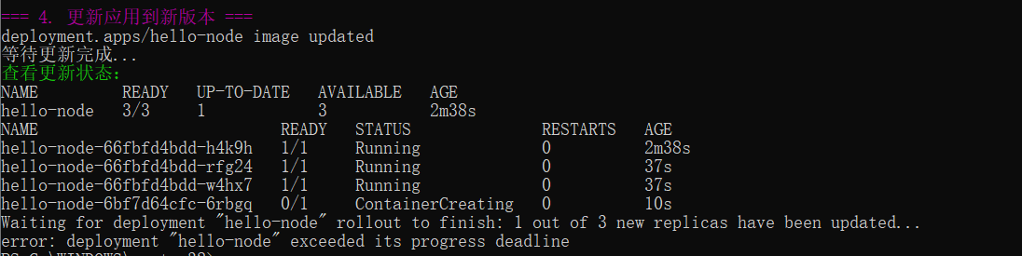kubectl rollout status deployment/hello-node
Note: Update exceeded progress deadline due to pause container characteristics
kubectl rollout history deployment/hello-node

6. Problem Diagnosis

6.1 Network Issue Diagnosis
minikube ssh "docker images"
kubectl describe pods

7. Concepts Verified
- Deployment - Application deployment and management
- Pod - Smallest deployable unit in Kubernetes
- Service - Network access endpoint and load balancing
- Scale - Horizontal application scaling
- Rolling Update - Zero-downtime application updates
- kubectl - Kubernetes command-line tool proficiency

8. Commands Summary
Category | Command | Purpose
Environment | minikube start --driver=docker | Start Minikube cluster
Deployment | kubectl create deployment | Create application deployment
Service | kubectl expose deployment | Expose application as service
Scaling | kubectl scale deployment | Scale application replicas
Update | kubectl set image deployment | Update application image
Troubleshooting | kubectl describe pods | Detailed pod information

9. Learning Outcomes
- Successfully set up local Kubernetes environment with Minikube
- Deployed and managed applications using Kubernetes resources
- Implemented core Kubernetes features: Deployments, Services, Scaling, Updates
- Troubleshot real-world network restriction problems
- Adapted to constraints by using available resources
- Gained practical experience with kubectl commands

10. Conclusion
This lab successfully demonstrated all core Kubernetes functionalities despite network constraints. The adaptation from the original tutorial (using pause image instead of echoserver) provided valuable problem-solving experience while still validating all key Kubernetes concepts.
The hands-on experience with Deployment creation, Service exposure, application scaling, and rolling updates provides a solid foundation for further Kubernetes learning and practical application in real-world scenarios.

